Exercise 10 - Pipes And Filters

1. Review questions
2. In a multi-stage pipeline involving five child processes, which process's exit value is in **$?** when the pipeline completes?

The last one

1. Which program may be used to save intermediate data as it flows through a pipeline.

tee

1. What does **tail -n +2 file** command do?

See from 2nd line and use tail command to write the file in real time

1. What are the methods of providing data through standard input?

<|

1. What are the methods of providing data to the **tr** command ?

-s, -d, -c

1. Become familiar with simple with grep searches.

We are going to start by making a file called ***country.txt*** in your home directory, which will be a comma-separated set of data for use in some of the following questions.   
Each row in the file corresponds to a single country, with each item of data separated by a comma. The following data fields are provided:

1) country name

2) capital city

3) local currency

4) official language(s)

If any field is not defined, a hyphen (-) is used as a placeholder. If a country has more than one language, extra columns are added to the row for each additional language, therefore the rows do not have the same number of columns.

The following line shows typical data from this file:

england,london,gbp,english

usa,washington,usd,english

china,beijing,rnb,chinese

germany,berlin,euro,german

france,paris,euro,french

italy,rome,euro,italian

canada,ottawa,cad,english/French

Using **less** or **more**, examine the **country.txt** in your home directory, to become familiar with its contents.

1. 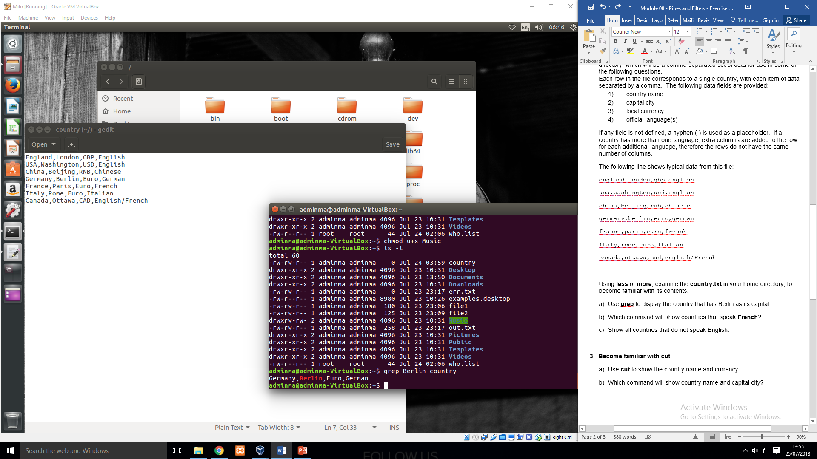Use **grep** to display the country that has Berlin as its capital.
2. Which command will show countries that speak **French**?

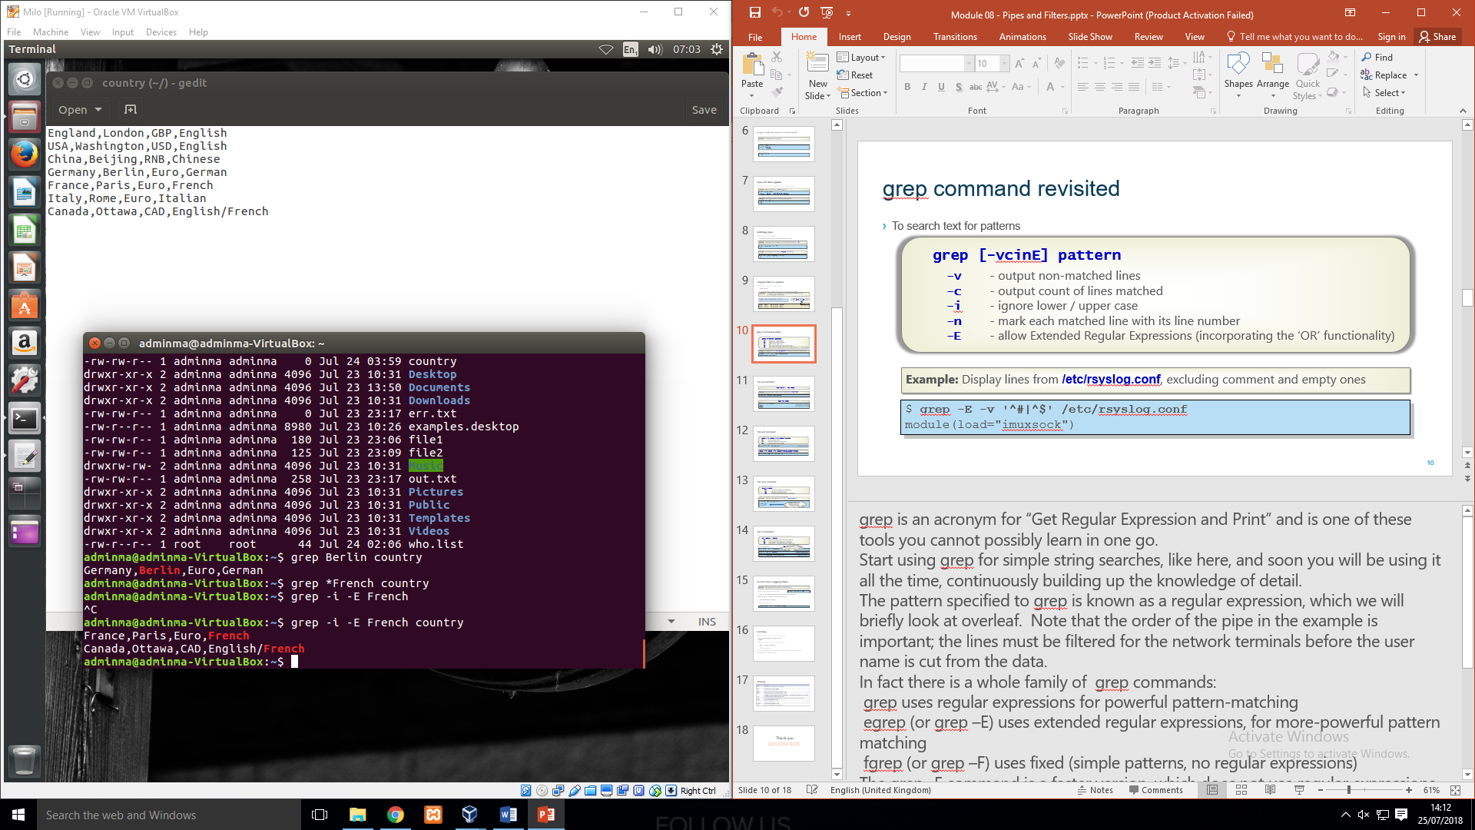

1. Show all countries that do not speak English.

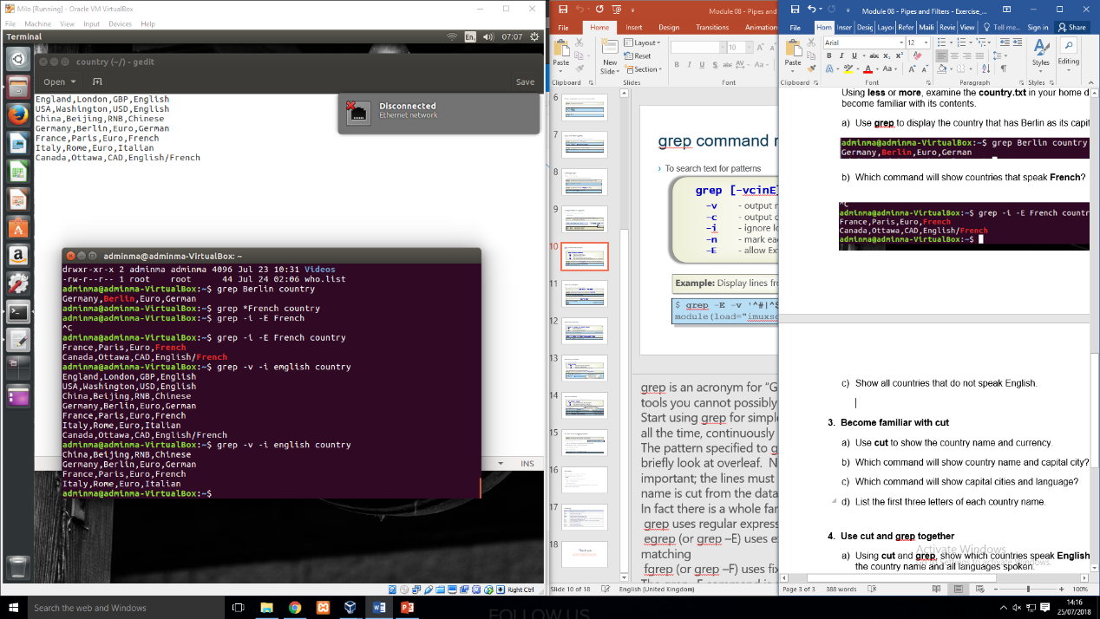

1. Become familiar with cut
2. Use **cut** to show the country name and currency.

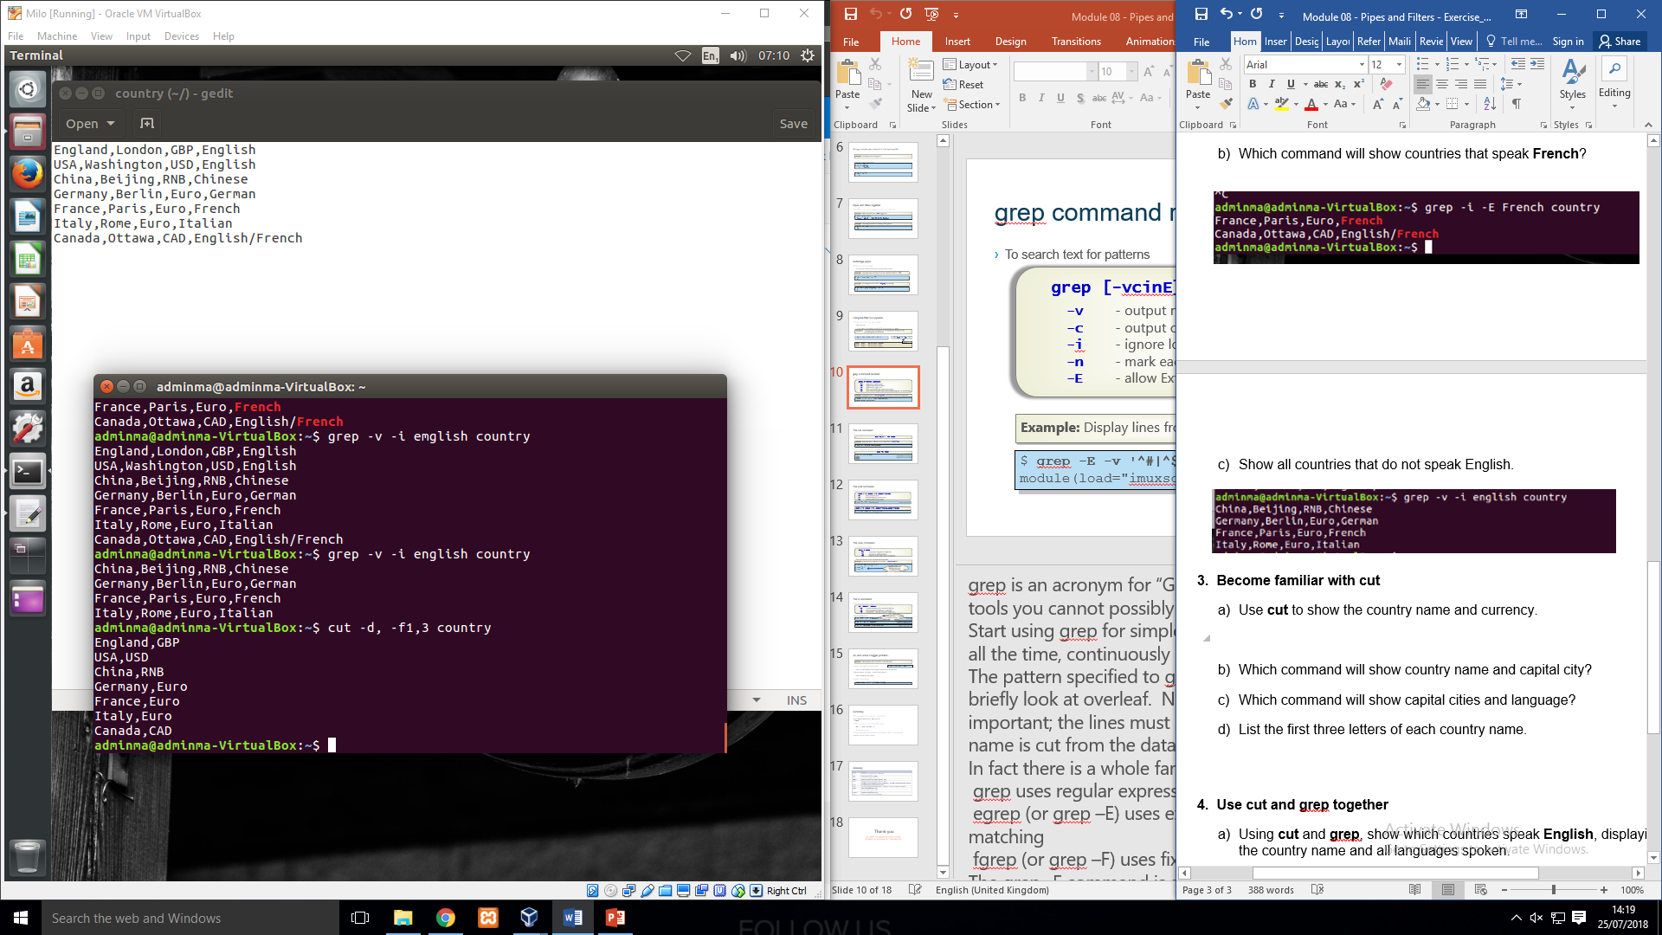

1. Which command will show country name and capital city?

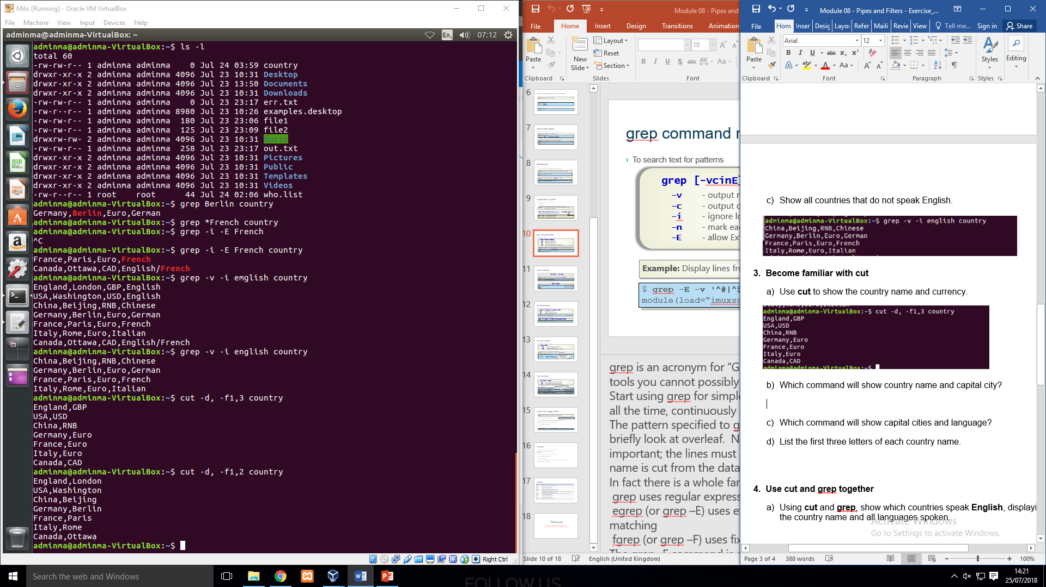

1. Which command will show capital cities and language?

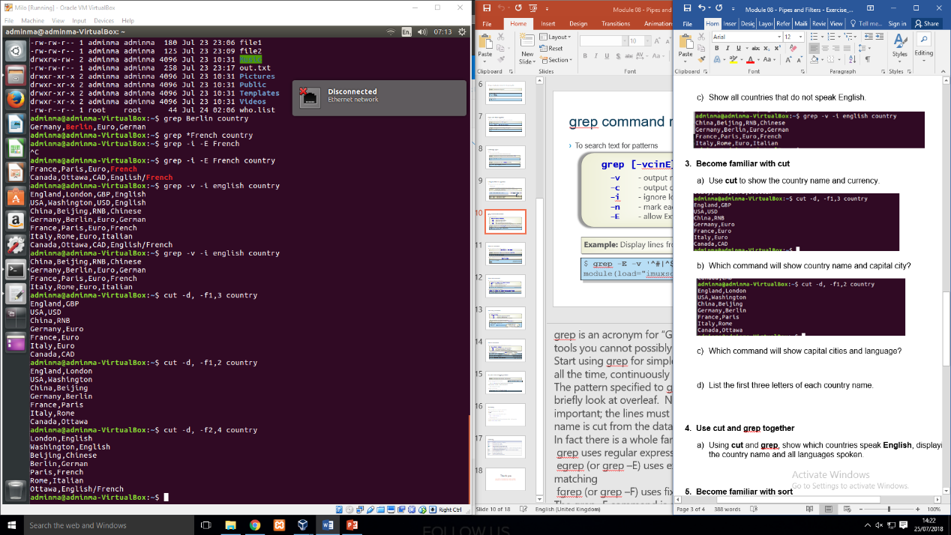

1. List the first three letters of each country name.

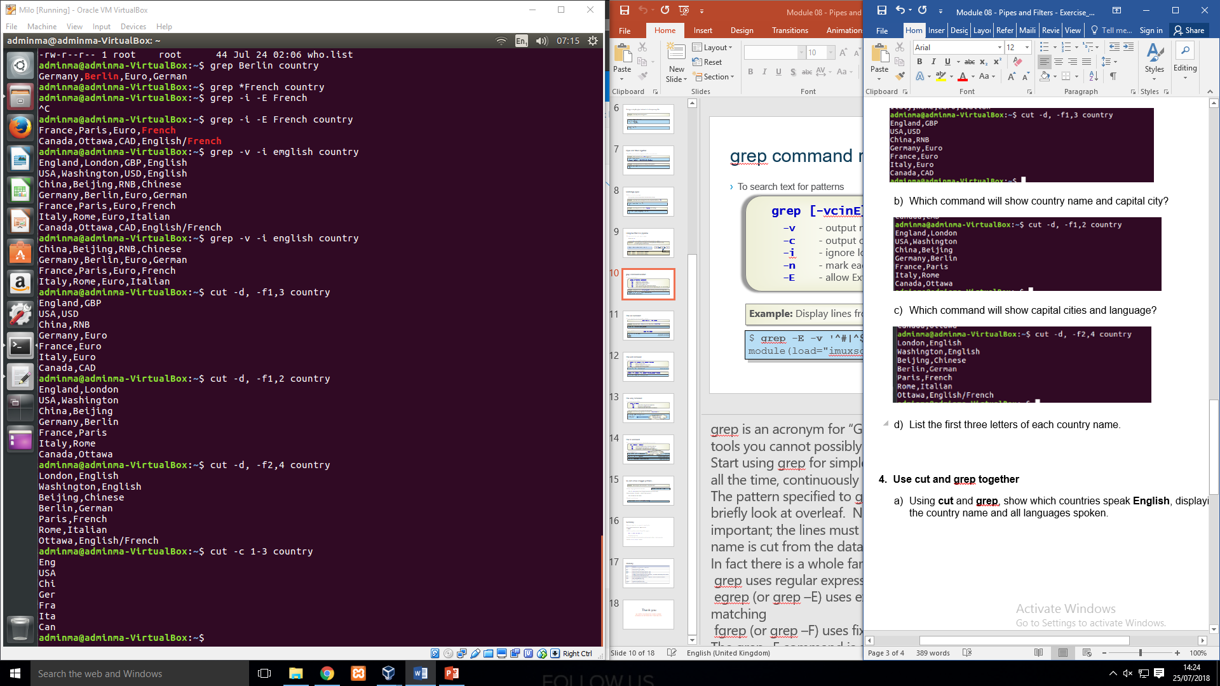

1. Use cut and grep together
2. Using **cut** and **grep**, show which countries speak **English**, displaying the country name and all languages spoken.

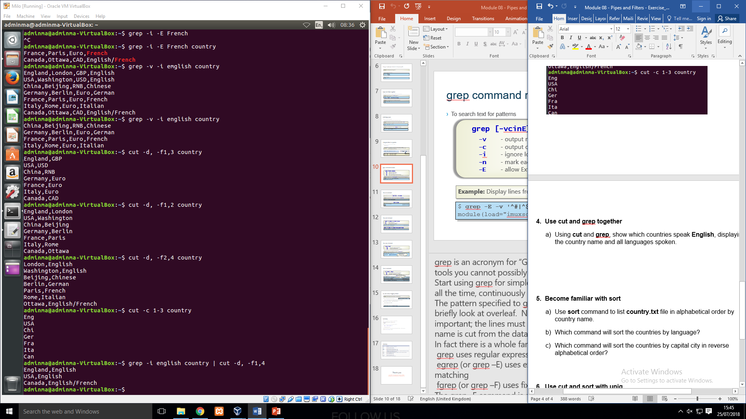

1. Become familiar with sort
2. Use **sort** command to list **country.txt** file in alphabetical order by country name.

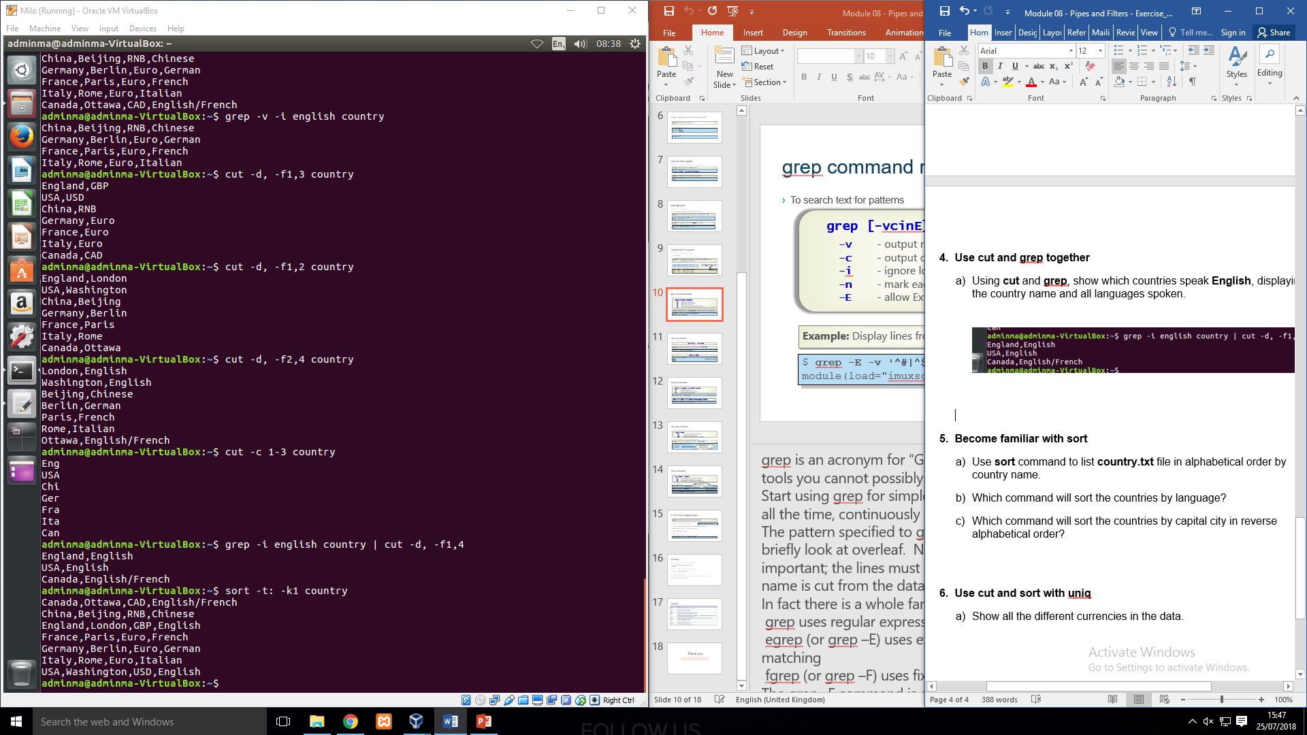

1. Which command will sort the countries by language?

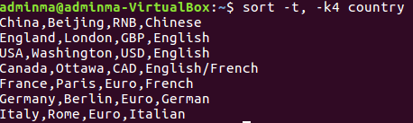

1. Which command will sort the countries by capital city in reverse alphabetical order?

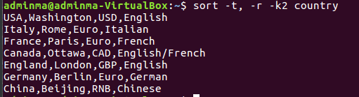

1. Use cut and sort with uniq
2. Show all the different currencies in the data. 